Census based Traffic Accident Severity Analysis in China and its Influential Factors

Wang, De-Yua; Ma, Liang*a; Zhang, Weia ; Zhang Yi-Jing b

*aDepartment of Industrial Engineering, Tsinghua University, Beijing 100084, China*

*bNational Key Laboratory of Human Factors Engineering, China Astronaut Research and Training Center, Beijing, 100094, P.R. China*

*Corresponding author: Liang Ma, Ph. D, Associate Professor

Postal address:

Department of Industrial Engineering, Tsinghua University, 100084, Beijing, P. R. China

Tel.: +86-10-62792665; Fax: +86-10-62794399 E-mail: liangma@tsinghua.edu.cn

**Abstract**

*Background:* In recent decade, despite the decrease in average road traffic fatalities per capita, severity of accidents in terms of fatality rate and injury rate have been on the rise in China. *Purpose:* The purpose of this study is to find key factors causing the increase of the accident severity in road traffic in China from 2000 to 2012.

*Method:* The severity of traffic accidents is measured by two factors: Human Damage Level (HD) and Fatality Rate (FR). National census figures under different categorizations are used to analyze the severity of different types of accidents, and further to analyze the key factors contributing to the rise of accident severity. Local data of major cities and provinces are also compared with national census figures to check the consistency of the data.

*Results:* The overall HD of accidents in China has increased by 75.33% from 2000 to 2010, while the FR has increased by 11.5%. Severity of accidents on expressways has outgrown those on other types of road with an increase of 306.2% over the decade; fatality rate of freight vehicles is 53.4% higher than average; late night accidents also involve more fatalities than those happened in other periods of time; accidents caused by speeding have killed 37.7% more people per accident than those caused by other inadequate behaviors.

*Conclusion & Practical implementation:* An opposite trend was found between the decline of traffic accidents and the increase of accident severity. Casual factors were analyzed based on census data, and it confirmed that the release way of the impact energy and the protection worn by the victims are key variables contributing to the severity of traffic accident.

*Keywords:* Traffic accidents; Accident severity; fatality rate; driving safety; vulnerable road user; China;

# Introduction

Since 2004, when the new Law of Road Traffic Safety was enacted in China, traffic accident and fatality numbers have both been declining. However, traffic accidents are actually becoming more severe and fatal in recent years by comparing the number of injuries and fatalities over the number of traffic accidents (see Figure 1). In this study, we propose to measure the severity of road traffic accidents by average human damage (number of fatalities and injuries over number of accidents) and fatality rate (number of fatalities over number of fatalities and injuries). Under the new scheme, the figures in China are significantly higher than those in Western world (see Figure 2 and Figure 3). It is of high priority to find out methods to lower the risk in any single accident.

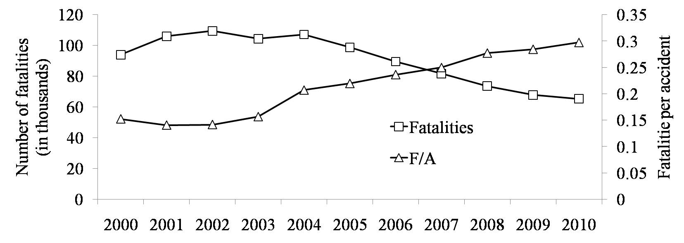

Figure 1. The number of traffic fatalities and fatalities per accident (F/A) in China

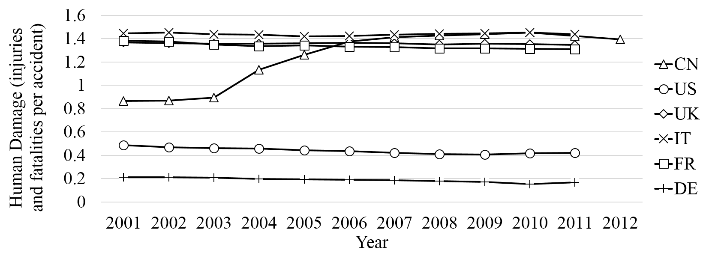

Figure 2. Average Human Damage of accidents in China and Western Countries (CN: China, US: United States of America, UK: United Kingdom, IT: Italy, FR: France, DE: Germany)

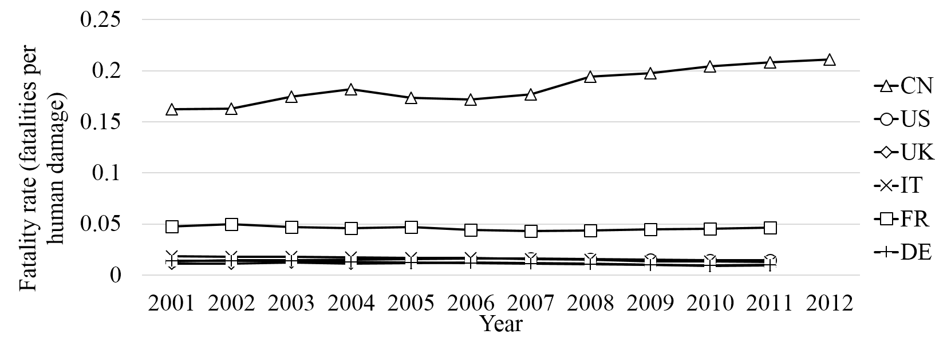

Figure 3. Fatality Rate of accidents in China and Western Countries (CN: China, US: United States of America, UK: United Kingdom, IT: Italy, FR: France, DE: Germany)

As for the total number of accidents, given the continuing fast development of road traffic in China, the traffic volume is projected to keep increasing in the near future. Highway mileage is projected to increase by 12% from 2010 to 2015. Other types of road traffic infrastructure are also targeted to be improved and expanded significantly in next five years (National Development and Reform Commission, 2012). Therefore, it is of significance to know the influential factors on the severity of traffic accidents to reduce more fatalities caused by traffic accidents.

Understanding traffic accidents in terms of their severity is important. For any road transport participants, it is vital to avert accident in any situation. Meanwhile, on condition of an accident involving injuries or fatalities, the odd of death is a more important indicator that represents the severity of accidents under certain circumstances. Knowing the underlying reasons that lead to fatalities in accidents, road users could manage their travel more wisely, and traffic administrative offices could take more effective measures to promote a safer transporting environment.

Fatalities in an accident are the result of a series of causes including people, vehicle, road, and environment (Sha, 2006). Traffic accidents, especially fatal ones, should always be avoided under any circumstances by controlling these factors. Before a collision, driving behavior and vehicle features determine the impact energy during the accident and the way in which the energy is released. After the collision, the chance of survival depends on the vehicle structure, the restraint system and the protection equipment for people involved in the accident, together with the level of medical treatment (Sánchez-Mangas, 2010).

Traffic participants, including motor vehicle drivers, non-motor vehicle drivers, pedestrians and passengers, are victims of traffic accidents. Their behaviors, such as risky driving behavior, determine the motion of the collision and the human damage level in an accident (Parker et al. 1995; Ren, 2010). Some personal factors may imply some potential differences in driving behavior, such as age, driving experience, and other natural characteristics (Yan et al, 2013). Regarding non-drivers, violations of traffic rules and laws are potentially dangerous to themselves and the other traffic participants. Road characteristics and the related facilities can also generate influences on the behavior of traffic participants (Pei, 2003). Vehicle factors are also important determinant factors to the severity of an accident. The discrepancies between parties of collision may also determine the overall energy released and the energy taken by each party during the accident. Besides that, the so-called passive safety characteristics are influential when a collision is unavoidable.

Regarding the severity of accidents, previous studies well investigated the micro-level mechanisms and statistics of fatal accidents. Savolainen, et al (2011) provided a review of traffic accident data characteristics as well as methodological alternatives and approaches for crash-severity data analysis. The study highlights the strengths and weaknesses of various methods mainly on statistical analysis of samples of individual accidents. Besides the studies reviewed by Savolainen, Ao (2010) discussed about the correlation between driver factors and accident hazard. Yong et al. (2011) investigated the accidents and related injuries with proper categorization and established the relation between injury and three aspects including vehicle type, safety device, and accident type. By distinguishing accidents under different conditions and investigating the mechanism behind, Wang (2009) produced similar conclusions as Yong et al. (2011). A more recent study on accidents in Guangdong province in China (Zhang (2013)) investigated into the correlations between risk factors and traffic violations and accident severity, but failed to distinguish severities of accidents with various characteristics.

In those studies, analysis about traffic accidents was more focusing on the quantities of accidents and fatalities, but few studies were conducted to analyze the severity of traffic accidents from a macro viewpoint. Evaluation indices commonly used include total quantity, quantity per unit of population, quantity per unit of registered vehicle, quantity per unit of vehicle miles traveled (VMT), and so on (Zhao, 2005). These indices are used to make time-series analysis or cross-country comparisons and to estimate overall traffic safety level on road. However, little is known about the severity of the accidents and its changes over time, since the index of fatalities per population is an indicator combining accidents per population and fatalities per accident. Even for fatalities per vehicle miles travelled (VMT), still it does not separate the severity of accidents from the probability of accident per VMT.

Besides the quantity of accidents, injuries and fatalities, the relative ratios of death over injury and non-injury are important in accident analysis. Valent et al. (2002) studied the accident figures in Udine, Italy and assessed the severity of these accidents by calculating such ratios. For China, although road safety has improved since 2004 in terms of total number of fatalities caused by accidents, we could still improve the road safety from a detailed perspective by evaluating the road safety in China in terms of fatalities and injuries per accident.

The purpose of this paper is to assess the severity of traffic accidents in China from a macro perspective and to find effective measures to reduce fatalities in traffic accident. Two new indicators are proposed to describe the severity of accidents and analyze the statistics according to categorization of accident conditions. The time-series data of two indicators are used to spot the factors that contribute to the changes in accident severity over time.

# Material and Methods

## *Data Source*

Traffic accident data are obtained from the following databases provided by the target countries (Germany, UK, USA, Italy, France, and China) (Eurostat, 2000-2011, NHTSA 2000-2010, NBSC, 2000-2010). These databases provide yearly traffic accident numbers and categorizations.

Data about China are from the National Statistics Bureau and Traffic Administration Bureau of Ministry of Public Security of PRC (TAB, 2000-2012). Local data are from provincial or municipal bureaus of statistics (AHPBS, 2000-2010; BJMBS, 2003-2010; FJPBS, 2003-2009; SBGDP, 2005-2010; HNPBS, 2005-2010; JSPBS, 2000-2009; SHMBS, 2002-2010; SCPBS, 2004-2010). Annual figures of the number and categorization of traffic accidents from 2000 to 2010 are archived in details and taken for the severity analysis.

According to the data provided in Traffic Accident Yearly Reports, causal factors are classified into various categories (see Table 1) to identify key factors influencing the severity of an accident. Those factors are selected according to previous literature concerning traffic accident analysis. Traffic accidents data for several provinces or municipals are collected to compare the conclusion of national level with that in a local context. Though local statistics data provide less categorized data, it is expected that the congregated local accident figures should not deviate from national data.

Table 1 Proportion of various means of transportation for victims upon accident (a Primary causal factor of a category is the direct context of the accident categorization.)

|  |  |
| --- | --- |
| Item | Category |
| A | Road class |
| B | Vehicle usage property |
| C | Geometric aspects of crashes |
| D | Traffic separation |
| E | Accident location |
| F | Accident time of the day |
| G | Primary cause |
| H | Intersection control |
| I | Driving experience |

## *Severity Evaluation Indicators*

An injury-death-accident factor is proposed to describe human damage level caused by traffic accidents, as shown in Eq. 1.

*f*HD=(*F*+*I*)/*A* (1)

where is human damage level (HD for short), is the fatalities caused by accidents per year, is the injuries caused by accidents per year, and is the total number of road traffic accidents per year.

Besides the human damage level, another one to describe the severity of an accident is the fatality rate (FR for short), as shown in Eq. 2.

*f*FR=*F*/(*F*+*I*) (2)

In this factor, only accidents involving human damage are taken into consideration. Thus minor accidents such as scratches would be neglected, and the average severity of traffic accidents could be more accurately estimated. Similar calculation was used by Hayakawa (2000) to evaluate the lethality of accidents.

## *Method*

By comparing the casualty rate indicators in various situations under different categorization methods, we locate the major factors that influence the severity and fatality of traffic accidents. The magnitudes of the indicators as well as the trends of them are assessed both graphically and numerically. Under a certain categorization method, if the difference in magnitudes between various data sequences are significant, then the factor, based upon which the data is categorized, is influential for the severity of accidents. On the other hand, if the trends of two data sequences are different, then there exist other factors that affect the severity of accidents and these factors are directly related to the specific category.

We used non-parametric Kruskal-Wallis (K-W) test to assess the equality between groups of time-series data, thus to evaluate the effect of categorical factor levels under each types of accident categorization method. The categorization type is treated as a variable with multiple levels. Quantified results of K-W test will indicate the significance of difference between different levels of that variable.

Linear regression was used to inspect the trend of the accident severity under different conditions. Time series data of each level under certain way of categorization provide hint to how different factors affect the severity of accidents. The slope of the regression function of one level is compared with the others under a certain way of categorization to find out the impact made by the corresponding factors on the severity of accidents over time. The *p* values of the regression reflect the significance of those trends.

# Results

## *Overall Severity of Accidents*

A comparison between China and major motorized countries is shown in Figure 2. Human damage index of China increased more significantly than those of other countries. After 2003, there is a major increase of the human damage level. The index increased by nearly 60%. On the contrary, human damage levels in other countries have a stably declining trend or relatively stable.

In terms of fatality rate in accidents, Chinese road traffic has long been in bad condition. As shown in figure 3, the death rate in China is significantly higher than other countries. Besides, on contrary to the slightly declining trend in other countries, death rate in China has been on the rise in recent years.

## *Composition of road users in traffic accidents*

China is a country with 1.3 billion people and motorization rate has not begun to rise significantly until 1990s. In terms of motorization rate, the average number of passenger cars per capita is much smaller than that of other highly motorized countries (see Figure 4). Besides, vehicle type mix on the road has increased in recent years. Light passenger cars increased in proportion, showing a larger vehicle mix over the years (see Figure 5).

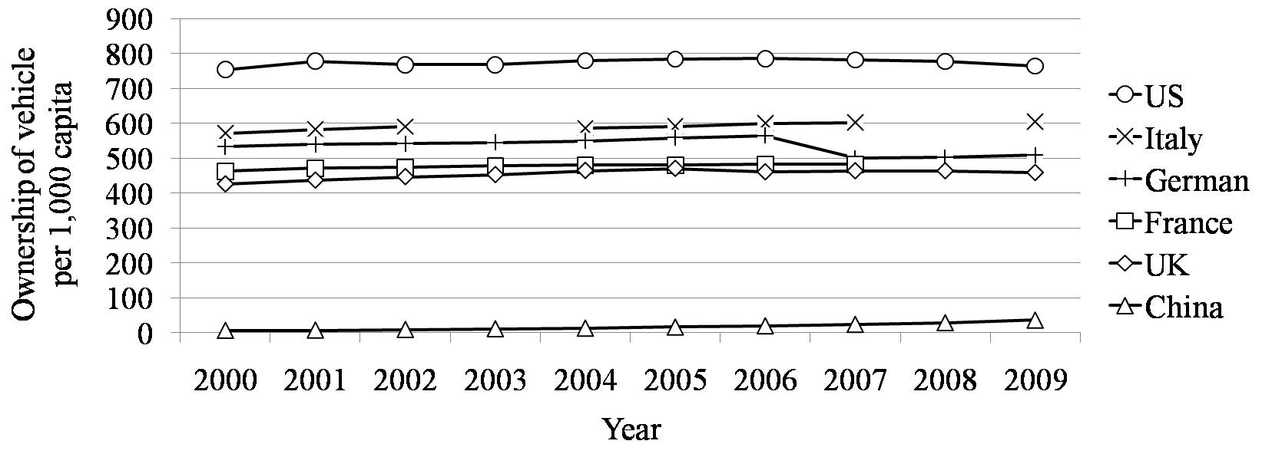

Figure 4. Level of motorization in major economies

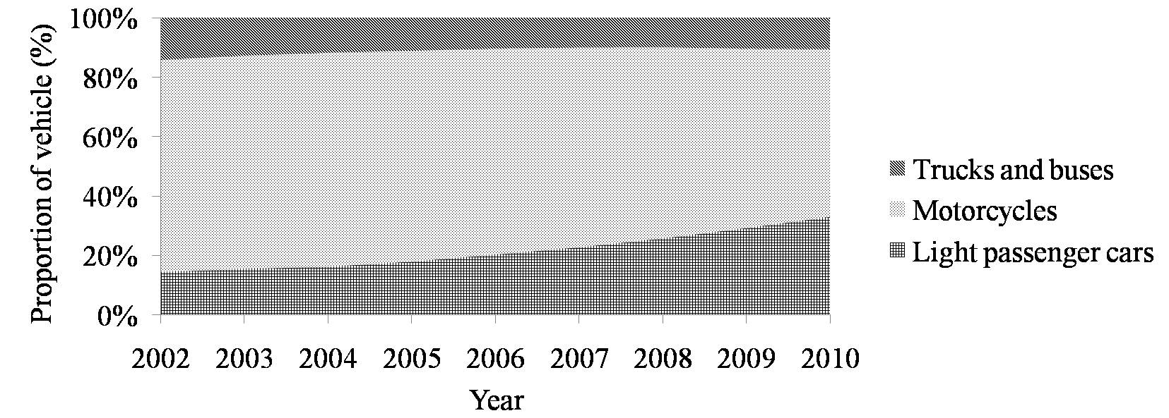

Figure 5. Vehicle mix of China, grouped by size and weight of vehicles

As shown in the statistics and suggested by Tay (2003), higher level of motorcycle mix would lead to higher frequency of fatal crashes. Pedestrians, cyclist, and riders are poorly protected in comparison with drivers and passengers in cars or trucks, and are more likely to suffer severe injuries or die in a crash. These vulnerable road users still take up a large proportion of victims of accidents in China (see Figure 6).

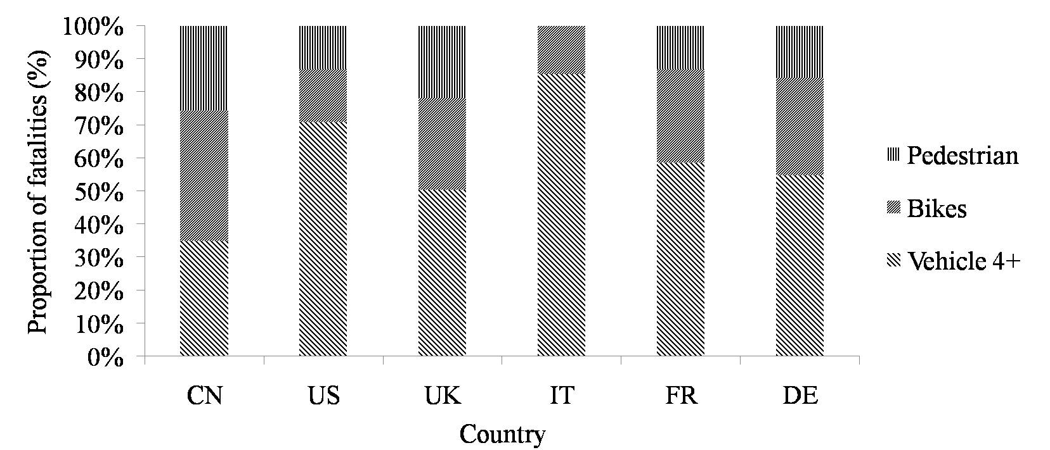

Figure 6. Means of transportation of the victims in accidents

## *Categorized Accident Analysis*

*Categorical Factor ANOVA*

The tests of ANOVA under different categorization method indicate that six variables have significant influence on the fatality rate of traffic accidents. However, human damage level is hardly affected by the condition of the accidents. The result is listed in Table 2.

Table 2 Results of ANOVA for different categorization method

|  |  |  |  |  |  |
| --- | --- | --- | --- | --- | --- |
| Variable | Number of levels | Human Damage | | Fatality Rate | |
| *F* | *p* | *F* | *p* |
| Road class | 5 | 6.20 | 0.184 | 42.00 | 0.000 |
| Vehicle usage property | 2 | 0.33 | 0.565 | 9.80 | 0.002 |
| Geometric aspects of crashes | 3 | 2.35 | 0.309 | 21.95 | 0.000 |
| Traffic separation | 4 | 5.11 | 0.164 | 27.52 | 0.000 |
| Accident location | 2 | 1.84 | 0.175 | 1.32 | 0.251 |
| Accident time of the day | 6 | 3.90 | 0.564 | 54.07 | 0.000 |
| Primary cause | 3 | 3.96 | 0.138 | 26.67 | 0.000 |
| Intersection control | 2 | 0.82 | 0.364 | 0.46 | 0.496 |
| Driving experience | 4 | 0.47 | 0.926 | 0.75 | 0.861 |

*Linear Regression*

We treat the human damage and fatality rate data of each year in each categorization as responses of different levels in traffic conditions and make linear regression models for each series of data. The result is shown in Table 3 and Table 4. Among the 9 factors we analyzed, severity under all conditions except for fatality rate on separated vehicle roads demonstrates increasing trends. Most of the trends are significant, with slopes of around 10%.

Table 3 Results of Linear regression of Human Damage in for different categorization method

|  |  |  |  |  |  |  |  |  |
| --- | --- | --- | --- | --- | --- | --- | --- | --- |
| **Road class** | | | **Vehicle usage property** | | | **Geometric aspects of crashes** | | |
|  | ***a*** | ***p*** |  | ***a*** | ***p*** |  | ***a*** | ***p*** |
| Expressway | 0.188310 | 0.000 | Freight vehicle | 0.056957 | 0.002 | Head-on | 0.049931 | 0.000 |
| Class I | 0.076943 | 0.000 | Private use | 0.032981 | 0.004 | Side impact | 0.065455 | 0.000 |
| Class II | 0.071015 | 0.000 |  |  |  | Rear-end | 0.118390 | 0.000 |
| Class III | 0.060887 | 0.000 |  |  |  |  |  |  |
| Urban Road | 0.084368 | 0.000 |  |  |  |  |  |  |
| **Traffic separation** | | | **Accident location** | | | **Accident time of the day** | | |
|  | ***a*** | ***p*** |  | ***a*** | ***p*** |  | ***a*** | ***p*** |
| Mixed | 0.063760 | 0.000 | Motorway | 0.024258 | 0.001 | 22:00-01:59 | 0.086515 | 0.000 |
| Separated directions | 0.090253 | 0.000 | Mixed Road | 0.009336 | 0.122 | 02:00-05:59 | 0.091041 | 0.000 |
| Separated vehicles | 0.065263 | 0.000 |  |  |  | 06:00-09:59 | 0.075715 | 0.000 |
| Separated directions and vehicles | 0.084640 | 0.000 |  |  |  | 10:00-13:59 | 0.081460 | 0.000 |
|  |  |  |  |  |  | 14:00-17:59 | 0.076436 | 0.000 |
|  |  |  |  |  |  | 18:00-21:59 | 0.060599 | 0.000 |
| **Primary cause** | | | **Intersection control** | | | **Driving experience** | | |
|  | ***a*** | ***p*** |  | ***a*** | ***p*** |  | ***a*** | ***p*** |
| Speeding | 0.056468 | 0.000 | Signs and markings | 0.084348 | 0.000 | 1<a<3 | 0.081455 | 0.000 |
| Inadequate operation | 0.072978 | 0.000 | Uncontrolled | 0.051107 | 0.000 | 3<a<5 | 0.083140 | 0.000 |
| Fail to yield to traffic | 0.081908 | 0.000 |  |  |  | 5<a<10 | 0.087946 | 0.000 |
|  |  |  |  |  |  | 10<a<15 | 0.091538 | 0.000 |

Table 4 Results of Linear regression of Fatality Rate in different categorization method

|  |  |  |  |  |  |  |  |  |  |  |  |
| --- | --- | --- | --- | --- | --- | --- | --- | --- | --- | --- | --- |
| **Road class** | | | | **Vehicle usage property** | | | | **Geometric aspects of crashes** | | | |
|  | ***a*** | ***p*** | |  | ***a*** | | ***p*** |  | ***a*** | | ***p*** |
| Expressway | 0.007953 | 0.000 | | Freight vehicle | 0.008660 | | 0.008 | Head-on | 0.001198 | | 0.328 |
| Class I | 0.002979 | 0.011 | | Private use | 0.004122 | | 0.043 | Side impact | 0.001013 | | 0.189 |
| Class II | 0.005762 | 0.000 | |  |  | |  | Rear-end | 0.008580 | | 0.000 |
| Class III | 0.003402 | 0.001 | |  |  | |  |  |  | |  |
| Urban Road | 0.001497 | 0.184 | |  |  | |  |  |  | |  |
| **Traffic separation** | | | | **Accident location** | | | | **Accident time of the day** | | | |
|  | ***a*** | ***p*** | |  | ***a*** | | ***p*** |  | ***a*** | | ***p*** |
| Mixed | 0.001992 | 0.064 | | Motorway | 0.008778 | | 0.004 | 22:00-01:59 | 0.005035 | | 0.000 |
| Separated directions | 0.006896 | 0.000 | | Mixed Road | 0.008816 | | 0.008 | 02:00-05:59 | 0.005688 | | 0.001 |
| Separated vehicles | -0.00033 | 0.778 | |  |  | |  | 06:00-09:59 | 0.003094 | | 0.010 |
| Separated directions and vehicles | 0.001653 | 0.177 | |  |  | |  | 10:00-13:59 | 0.002135 | | 0.047 |
|  |  |  | |  |  | |  | 14:00-17:59 | 0.002948 | | 0.011 |
|  |  |  | |  |  | |  | 18:00-21:59 | 0.002204 | | 0.060 |
| **Primary cause** | | | | **Intersection control** | | | | **Driving experience** | | | |
|  | ***a*** | ***p*** | |  | ***a*** | | ***p*** |  | ***a*** | | ***p*** |
| Speeding | 0.008769 | 0.000 | | Signs and markings | 0.008778 | | 0.004 | 1<a<3 | 0.004929 | | 0.002 |
| Inadequate operation | 0.005627 | 0.000 | | Uncontrolled | 0.008816 | | 0.008 | 3<a<5 | 0.006795 | | 0.000 |
| Fail to yield to traffic | 0.007271 | 0.000 | |  |  | |  | 5<a<10 | 0.007280 | | 0.000 |
|  |  |  | |  |  | |  | 10<a<15 | 0.007081 | | 0.000 |

*Road class*

Among all the accidents, 25% happened on class II roads, 18% urban roads, 15% class III roads. Accidents happened on different types of road cause different levels of damage to the victims. In terms of human damage, expressways have surpassed other types of roads to reach a human damage rate of 2.07 in 2010. As for other types of road, human damage indices also increased by about 50% throughout 2000 to 2010.

The fatality rate of accidents on expressways is 53.9% higher than average, while the index of urban roads is 33.6% lower than average. Other types of road that have lethality higher than average include class II, class I, and class III (see Figure 7).

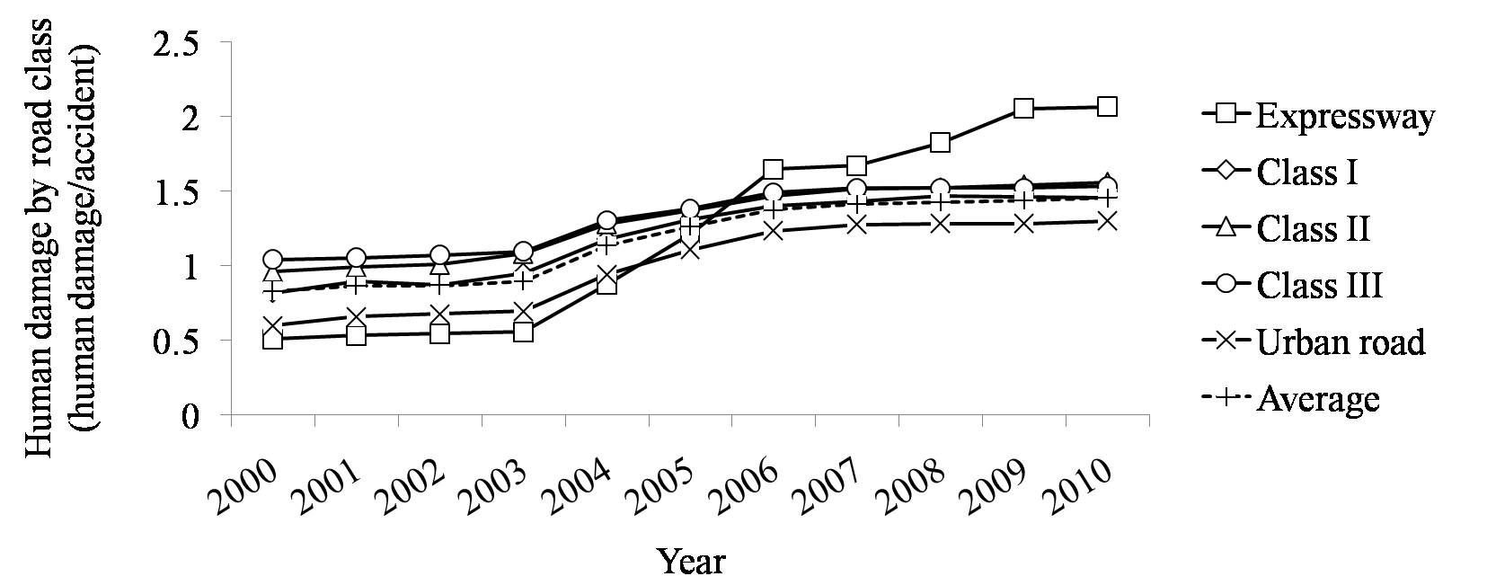

(a)

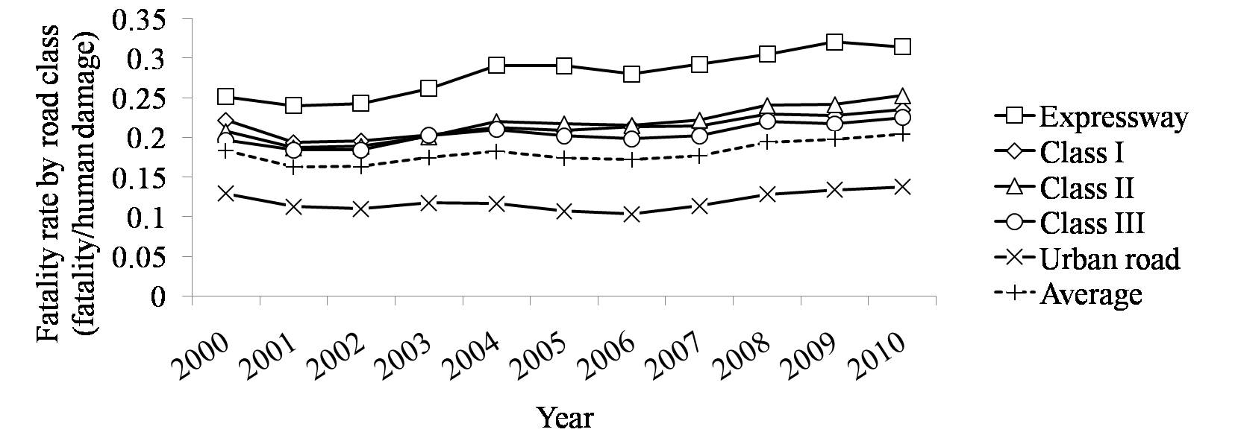

(b)

Figure 7. (a) human damage level in China grouped by types of road, (b) accidents fatality rate of China grouped by types of road







*Vehicle usage property*

Major types of vehicles that cause accidents include private use vehicles (49.7%, 2010), freight trucks (30.3%), intercity coaches (3.7%), taxis (1.7%), and buses (1.3%). For different types of vehicle responsible for an accident, the human damage levels and death rates are different. In accidents caused by trucks, human damage is the most severe. The increase rate of HD in coaches-related accidents is the highest among all vehicle usages (44.1%), followed by taxi-related accidents (34.9%). In terms of fatality rate, truck-related accidents (0.313) are 53% higher than average (20.4%). It is also the second fast-growing category between 2004 and 2010 (17.7%), following buses (27.5%) (see Figure 8). The correlation coefficient between fatality rate of freight-vehicle-involved accidents and private-use-vehicle-involved accidents is 0.946.

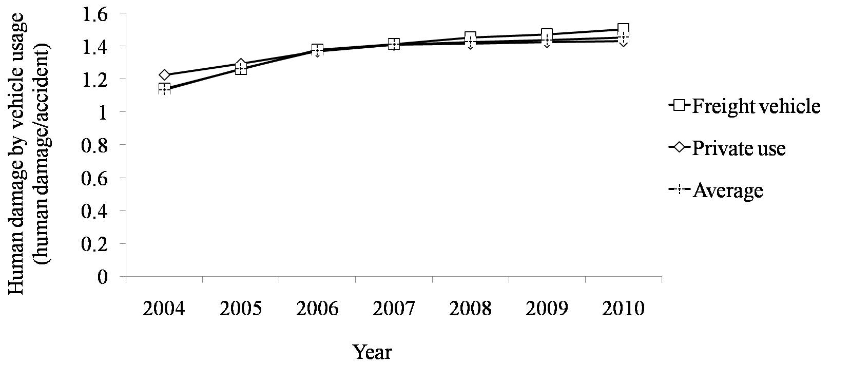

(a)

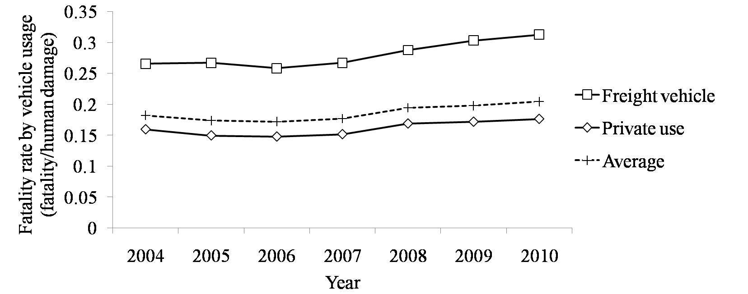

(b)

Figure 8. (a) Human damage level in China grouped by vehicle usage, (b) accidents fatality rate of China grouped by vehicle usage







*Geometric aspects of crashes*

Accidents are also categorized into various types of collision. Head-on collision (26.9%), side impact (25.5%), and rear-end collision (13.7%) account for the majority of accidents. Among them, rear-end collisions are the most deadly one, with HD of 1.6 and FR of 0.251, 10% and 23% higher than average, respectively. Rear-end collisions are also the fasted growing, with a 171.9% HD increase and a 41.7% FR increase from year 2000 to 2010. For both indices, the increase rates of rear-end accidents are significantly higher than other types of accidents (see Figure 9).

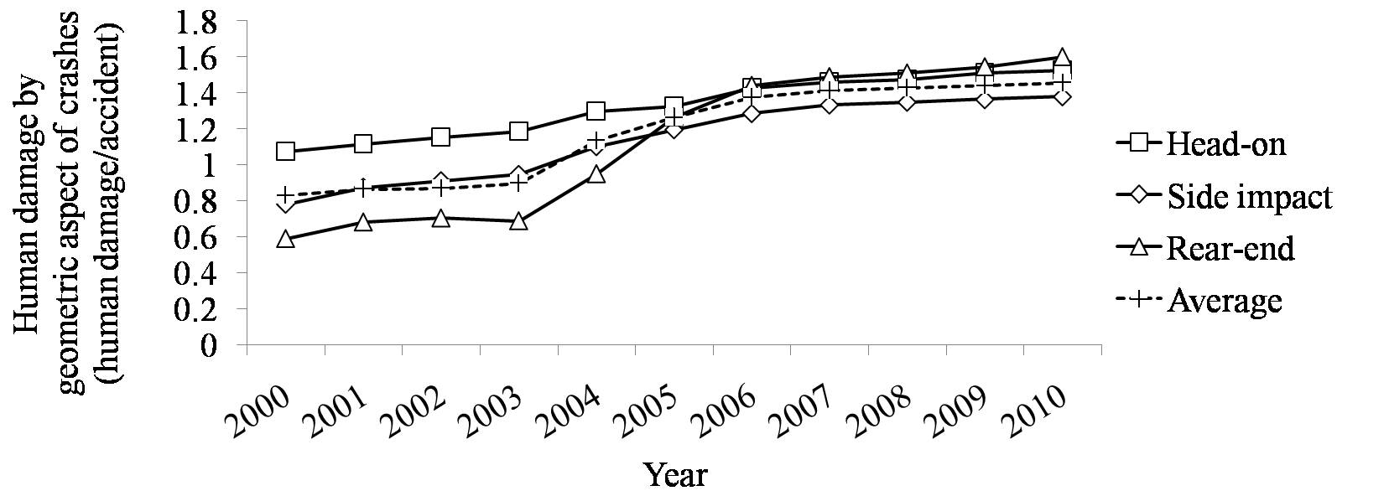

(a)

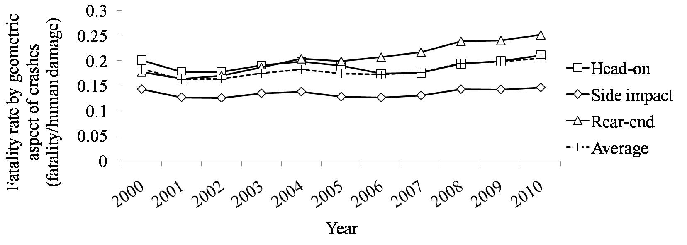

(b)

Figure 9. (a) human damage level in China grouped by geometric aspect of crashes, (b) accidents fatality rate of China grouped by geometric aspect of crashes







*Traffic separation*

Roads of different classes have different configurations. Roads that are most sufficiently equipped separate the traffic flow according to the types of the vehicle and their direction. Roads are also built with median to only separate traffic with different traveling directions, or with buffer zones only to separate motor vehicles from bicycles and pedestrians. Roads of the lowest grade have no structures to separate different traffic participants from each other.

Among four types of road configurations, separated direction roads have the highest fatalities rate of 0.232. This index is also the fastest growing among the four. Second to separated direction is the mixed road configuration, with an HD of 1.452 and a FR of 0.203. Noticeably, only separated direction configuration has an HD and a FR higher than average (see Figure 10).

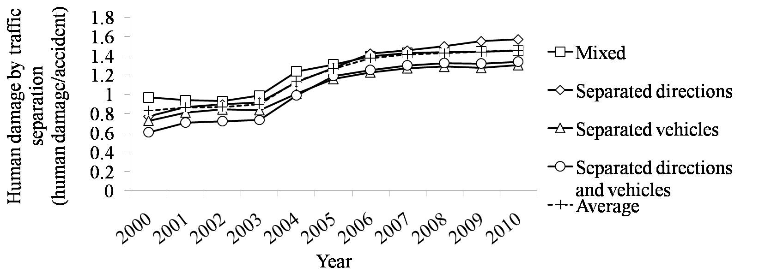

(a)

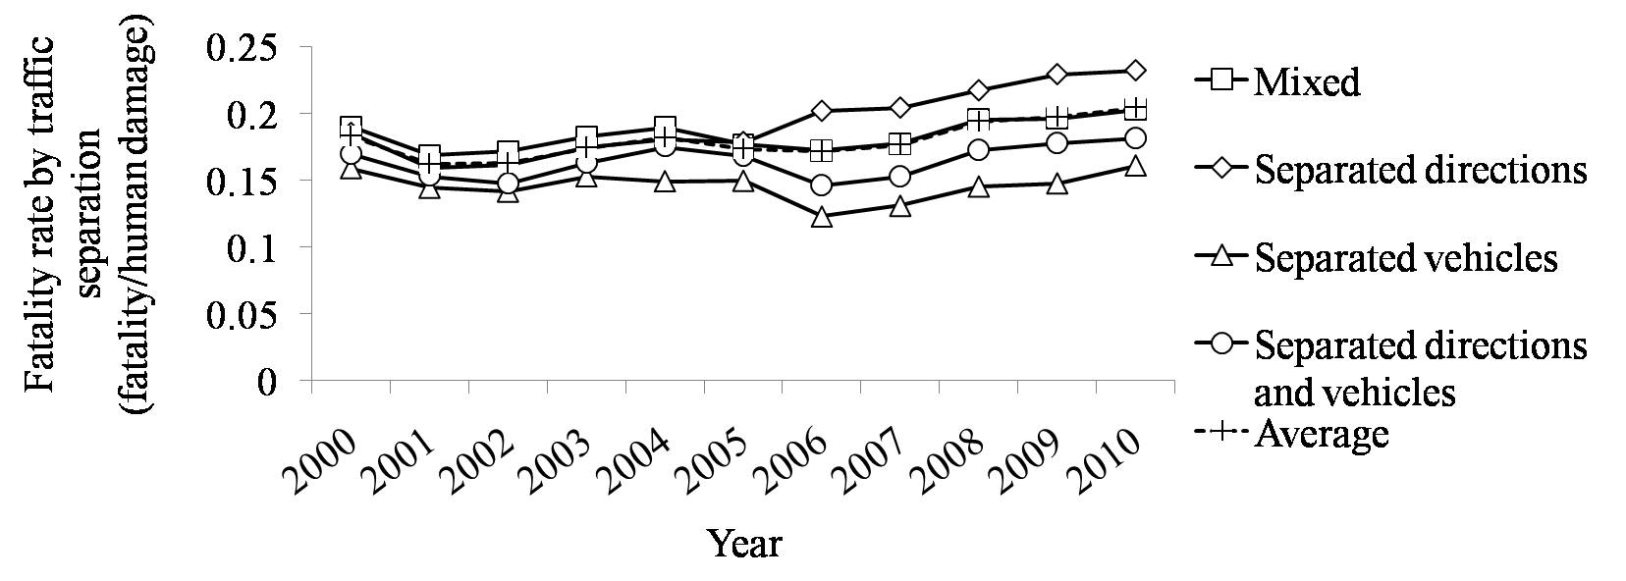

(b)

Figure 10. (a) human damage level in China grouped by traffic separation, (b) accidents fatality rate of China grouped by traffic separation







*Accident location*

Accidents incurred at different location of the road cause equivalent damage to victims and have similar rates of death. The indices of various categories show no significant differences between each other (see Figure 11).

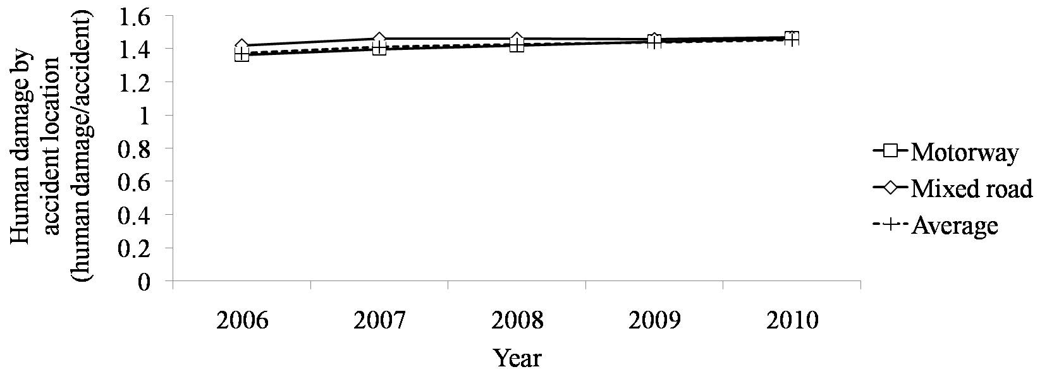

(a)

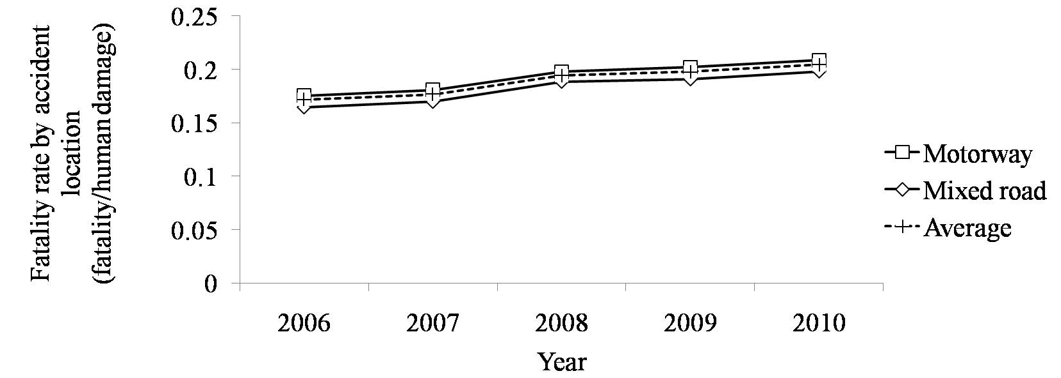

(b)

Figure 11. (a) human damage level in China grouped by accident location, (b) Accidents fatality rate of China grouped by accident location







*Accident time of the day*

As for the accidents incurred took place at different times of the day, there is no significant variation in the increase rate of HD from 2000 to 2010. Yet the time slots of midnight to dawn lead the increase of FR in these ten years. Accidents occurred at that time are also more likely to be fatal, with leading HD of 1.6 and FR of 0.308 (see Figure 12).

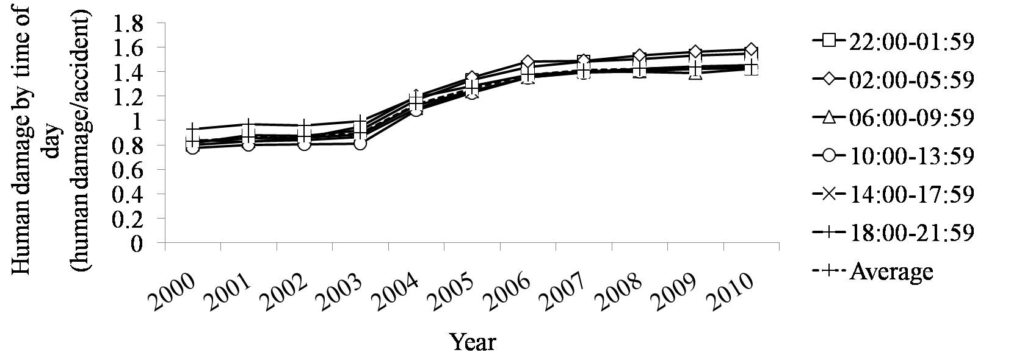

(a)

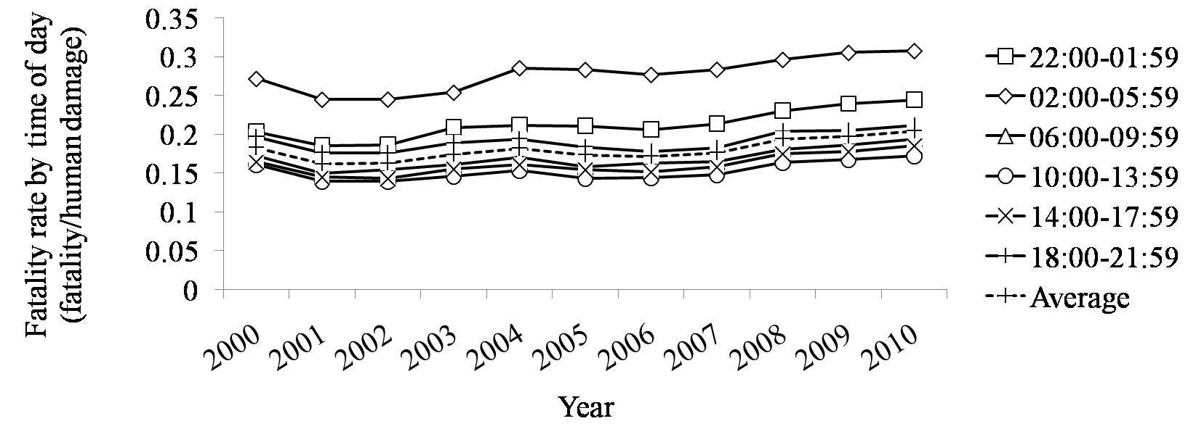

(b)

Figure 12. (a) human damage level in China grouped by accident time of the day, (b) accidents fatality rate of China grouped by accident time of the day







*Primary cause*

The cause of an accident is directly connected to its consequences. The most devastating types of accidents are caused by speeding, with an HD of 1.497 and a FR of 0.281, which are significantly higher than the average of 1.455 and 0.204 (see Figure 13). Accidents caused by failure to yield to traffic have increased their severity with much higher increase rate than others.

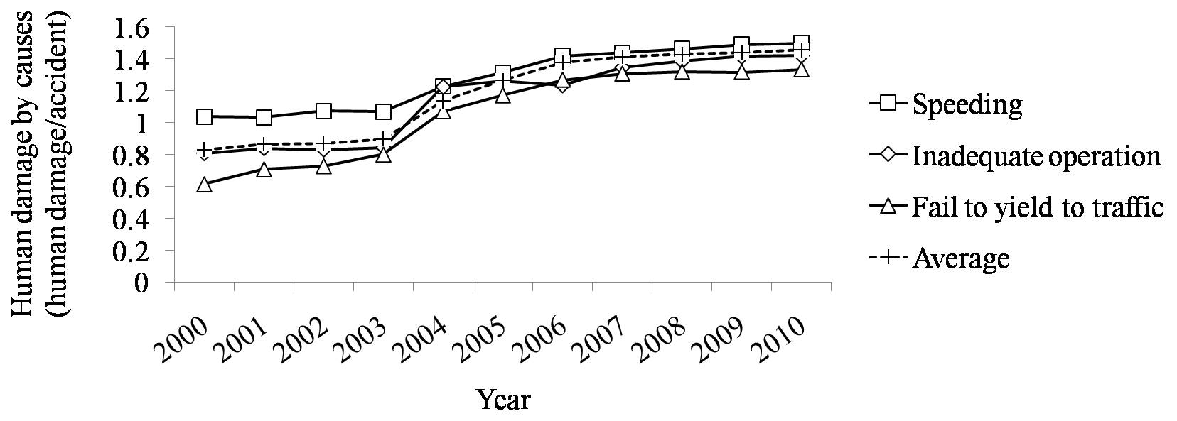

(a)

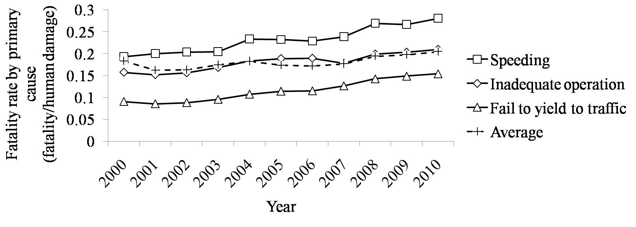

(b)

Figure 13. (a) human damage level in China grouped by primary cause, (b) accidents fatality rate of China grouped by primary cause







*Intersection control*

Most deaths in accidents incurred at intersections with only signs or markings as guidance (62.1%, 2010). The death rate of accidents occurred at intersections with signs and markings increased slightly faster and reached higher than average (0.216 to 0.204) (see Figure 14).

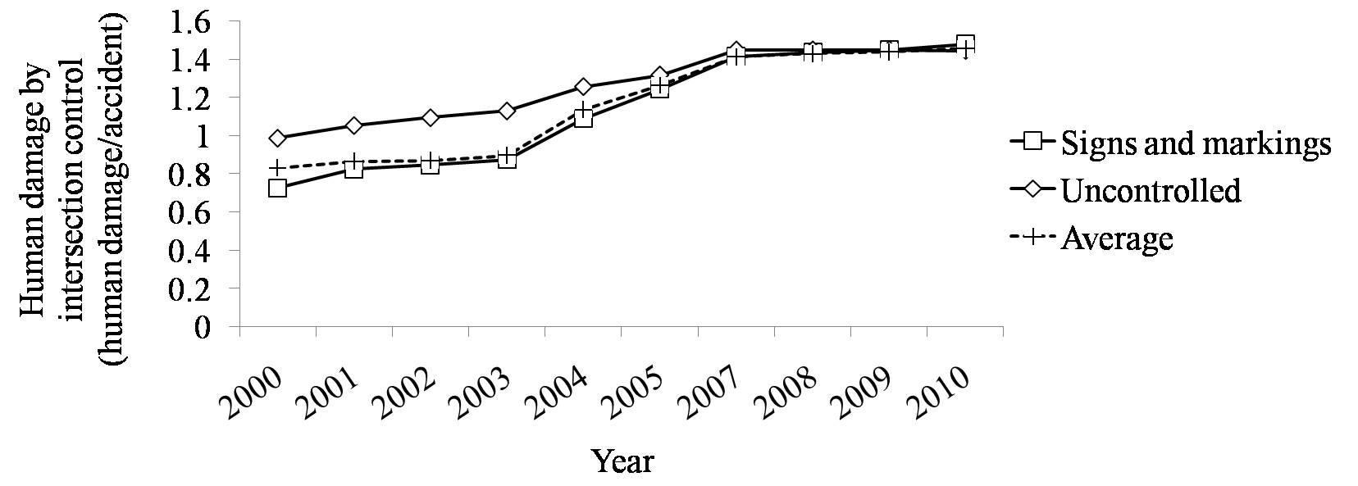

(a)

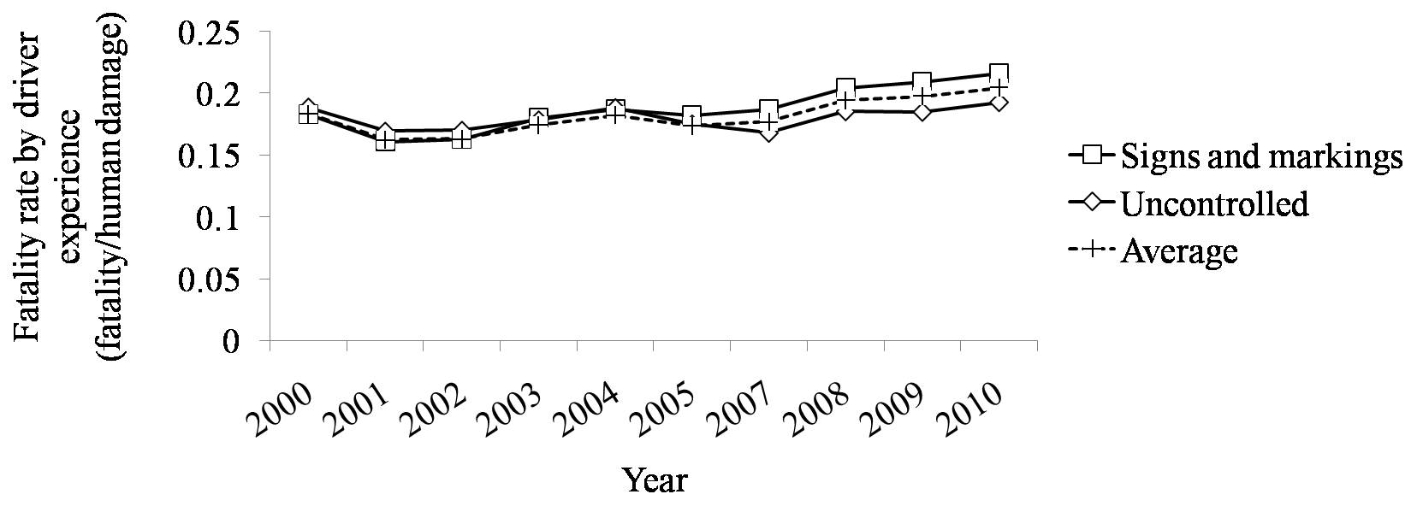

(b)

Figure 14. (a) human damage level in China grouped by intersection control, (b) accidents fatality rate of China grouped by intersection control







*Driving experience*

The severity of accidents has little relationship with the driving experience of the responsible driver. As is shown in the figure, the two indices show little variation across drivers with different experience (see Figure 15).

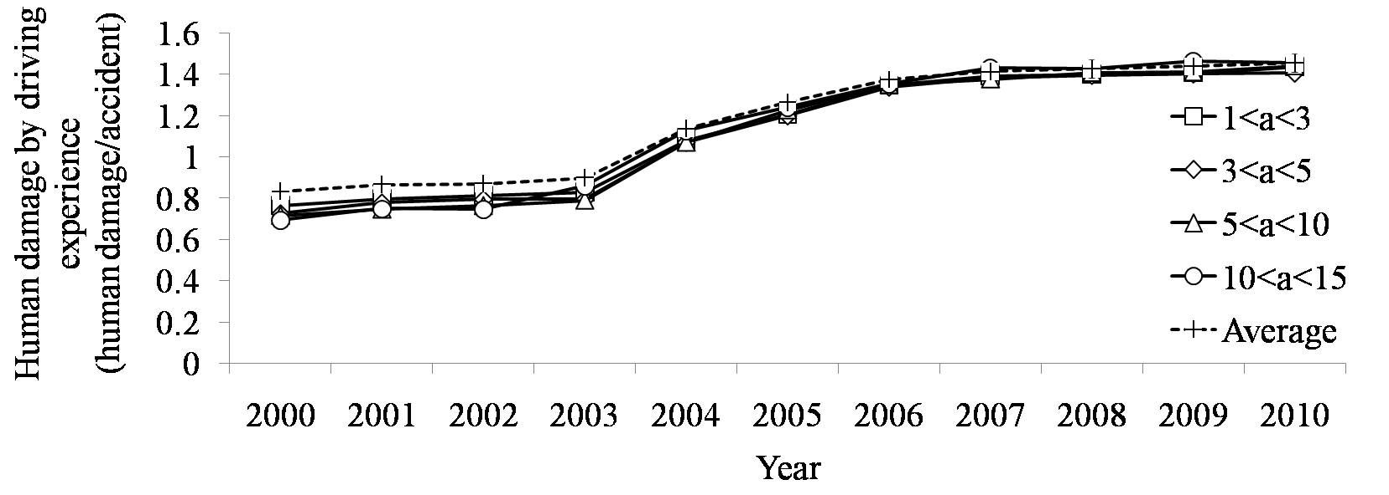

(a)

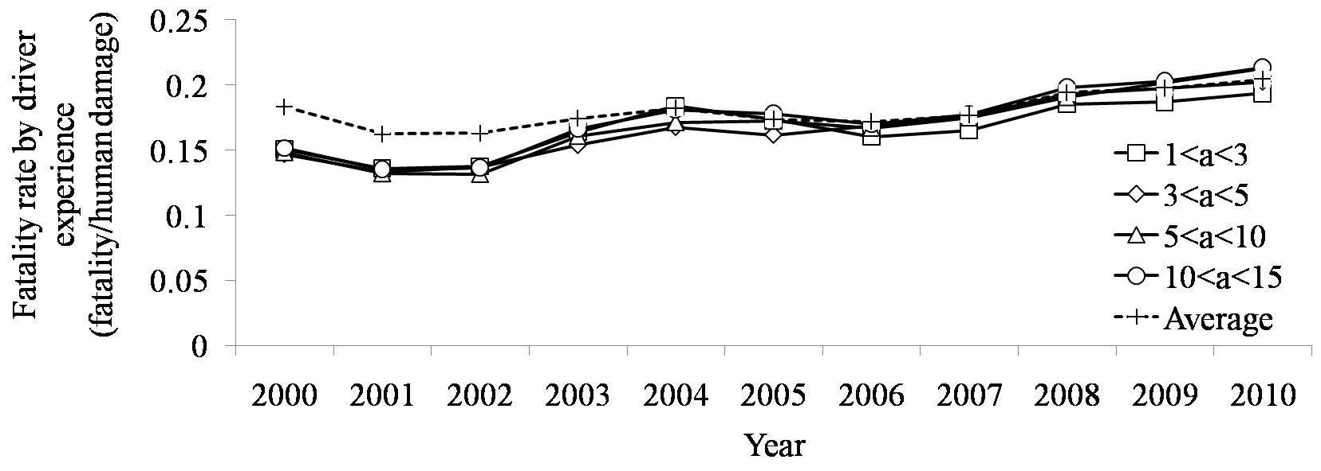

(b)

Figure 15. (a) human damage level in China grouped by driving experience, (b) accidents fatality rate of China grouped by driving experience







## *Local statistics figures*

To verify how much the analysis of fatality data could be applied to different parts of China, we compare the local statistics data collected by local authorities and the data prepared by national statistics bureau (see Table 12). Eight provinces or municipalities are investigated by comparing the deviation of data in a series of years, when both national and local statistics are available. Fatalities in the selected area account for 36.29% of total numbers in the nation. The provinces cover from highly developed metropolitans such as Shanghai to less developed provinces like Sichuan, in the western part of China.

Table 12 Deviation of national statistics figure from local statistics figure. Positive deviation indicates that the national data is larger than local data, while negative deviation indicates that national census data is smaller than the number reported to local authorities.

|  |  |  |  |  |  |  |  |  |
| --- | --- | --- | --- | --- | --- | --- | --- | --- |
| Deviation | Fatalities | Data range | daccident | sd | dfatalities | sd | dinjuries | sd |
| Guangdong | 6203 | 2005-2010 | -0.49% | 1.40% | -0.52% | 1.46% | -0.50% | 1.30% |
| Beijing | 974 | 2003-2010 | 0.43% | 1.01% | -2.27% | 4.06% | 0.87% | 1.17% |
| Shanghai | 1009 | 2002-2010 | 0.00% | 0.00% | -0.02% | 0.06% | -0.04% | 0.08% |
| Henan | 1825 | 2005-2010 | -0.05% | 0.05% | 0.73% | 1.39% | -0.10% | 0.07% |
| Sichuan | 2931 | 2004-2010 | -0.05% | 0.24% | -0.03% | 0.09% | -0.04% | 0.09% |
| Jiangsu | 5031 | 2000-2009 | 0.72% | 5.08% | 2.76% | 9.03% | 1.11% | 4.53% |
| Anhui | 2877 | 2000-2010 | -1.52% | 5.61% | -0.70% | 3.08% | -0.85% | 3.29% |
| Fujian | 2822 | 2003-2009 | -0.03% | 0.04% | -0.02% | 0.06% | -0.01% | 0.04% |

*In the header line of this table, *d* means deviation in terms of the subscript of the letter. For example, *daccident* means the proportion of change in accident numbers over 2005-2010.

# Discussion

## *Severity of Car Accidents*

In this article, we use two indicators to represent the severity of accidents in different scenarios under different conditions. The calculation takes the number of fatalities and injuries into account, which provides more accurate estimation of accident severity and likelihood of death. By comparing the average human damage per accident and the average fatalities per human damage, we could find evidence to support the initiatives of lowering the accident lethality from different aspects (Table 13).

Current statistics data provides strong evidence to some of the causal factors of fatal accidents. We find out that the leading factors that affect the lethality of accidents are road user protection and human behavior prior to accidents. These factors are directly related to how much and how energy is released during an accident. Based on this observation, we could draw some conclusion about how to lower the severity of accidents.

Table 13 Proportion of various means of transportation for victims upon accident

|  |  |  |  |  |
| --- | --- | --- | --- | --- |
| Item | Category | Categorical factora,b | Strong  Evidence | Causal factorsc |
| A | Vehicle mix | E | Yes | V (protection level)  E (traffic volume) |
| B | Road class | R | Yes | H (travelling status, including speed),  R (standards of infrastructure)  E (traffic volume) |
| C | Vehicle usage property | V | Yes | V (maximum number of passengers) |
| D | Geometric aspects of crashes | V | Yes | H (travelling status immediately prior to the accident)  V (vehicle structure, protection level) |
| E | Traffic separation | R | Yes | H (travelling status immediately prior to the accident)  R (standards of infrastructure) |
| F | Accident location | E | No | H (travelling status immediately prior to the accident)  E (types of road user) |
| G | Accident time of the day | E | Yes | H (travelling status immediately prior to the accident)  E (lightings, visibility, and other driving conditions) |
| H | Primary cause | H | Yes | H (travelling status immediately prior to the accident) |
| I | Intersection control | R | No | H (travelling status immediately prior to the accident)  R (standards of infrastructure) |
| J | Driving experience | H | No | H (travelling status immediately prior to the accident,  actions immediately after the accident) |

a Primary causal factor of a category is the direct context of the accident categorization.

b H=human, V=vehicle, R=road, E=environment.

c Secondary causal factors are direct factors that affect the severity of accidents.

## *Countermeasures*

*Protection for VRUs and Vehicle mix*

China is one of the most populous countries in the world. Before motorization, people travel either on foot or by bike. Later on, people begin to ride motorcycles. Only in recent years, the boom of passenger cars, together with the boom of freight vehicles, has been stimulated by the rapid growth of economy. The diversity of motor and non-motor vehicles on road begins to increase. That means the road users would adopt more diversified means of transportation. Pedestrian, cyclists, and riders still account for a larger proportion of road users on Chinese road than on other countries road. These traffic participants are regarded as vulnerable road users (VRU) (Wong et al, 2002).Kong and Yang (2010) draw some similar conclusion in their studies on pedestrian casualty risk in traffic accidents. When an accident happens, the chance of survival of anyone involved would be subject to the initial energy of the collision and the protection harnessed. In most cases, pedestrians, cyclists, and riders have no or very little protections of their body. As a consequence, road users in China are exposed to more dangerous environment than those in other countries. In other words, it is more likely in China than in other countries that a collision happens between two parties with much different levels of protection. This implication is verified by the statistics figures of proportions of various means of transport taken by the victims in accidents. A study by Zhuang and Wu (2011) revealed that the behaviors of pedestrians on roadway in China even increased the odds and severity of accidents.

Furthermore, when we compare the lethality of accidents happen on different separation configuration, we would find out that on roads that separate different types of vehicles, both human damage and death rate are lower than those of other accidents. Roads that only separate directions are designed to better guide vehicles and to avoid potential head-on collisions. Meanwhile, they also raise the average speed of the vehicles, putting pedestrians and cyclists to larger risk and greater danger once there is a collision.

To mitigate the effect of vehicle mix on severity of accidents, several countermeasures could be done. 1) Reduce the gap between larger vehicles like trucks and smaller vehicles like motorbikes or mini-cars, in terms of protection. 2) Make helmet for riders mandatory and take stronger measures in law enforcement. 3) Improve road infrastructure so that motor vehicles and other road users are physically separated (Zhang, 2010).

*Restriction of speed*

The severity of an accident is directly determined by the energy of the impact, which is correlated to the speed of the collision. Taking statistics figures of various categorization into consideration, we find out that, similar to what we have always been told, speed is the most significant determining factors in an accident.

According to various categorization methods, we find the following types of accidents cause more fatality than others, 1) expressway, 2) rear-end collision, 3) direction separated roads, 4) midnight to dawn, 5) speeding.

As has been verified in previous studies (Wang, 2008), traffic flows on expressway are much faster than on other types of road. This explains why accidents on expressways are more likely to be fatal. On direction separated roads, vehicle traveling speeds could be higher than other types of roads (State Council, 2004). When an accident happens, the energy is much higher than in other scenarios. As a consequence of high speed impact, accidents under these conditions are more likely to bring fatalities.

Several countermeasures could be carried out to alleviate the effect of speed. On Chinese roads, it is not uncommon to have some vehicles traveling at extremely slow speed. In most cases, the drivers are distracted to do secondary tasks such as having a phone call, text-messaging, setting up the navigation, etc. Such vehicles on road not only slow down the traffic flow, but also serve as moving obstacles for other vehicles. When there is a rear-end collision, the impact energy is still quite a bit. When there is a high-speed collision, it is very likely that both vehicles go out of control. Consequently, while we are regulating the vehicles with an upper speed limit, we should take serious effort to keep the vehicles moving above lower speed limit.

*Reduce truck- or bus-related accidents*

From the statistics figure we could find out that truck- and bus-related accidents causes much more injuries and fatalities than accidents of other types. As buses usually carry a large group of passengers, once there is an accident, it should be a major one, causing many people to get injured or to get killed.

Besides, trucks and buses are usually of great size and weight. In a collision, the smaller vehicle is under great disadvantage. Since trucks, especially trailers, usually have bigger chassis, the cargo container, or the main bodywork is usually higher than passenger cars. In a collision, the most devastating effect is that the smaller cars slides underneath the truck and get hit at the most vulnerable part of both the vehicle and the car users. To avoid car-truck collision under-rides, the government should make under-ride guards on trailers and trucks mandatory and set higher standards to make the guards more effective in all collision circumstances.

*Revised Statistics Scheme*

As verified by the current statistics figures, the severity of accidents is directly determined by the energy of the impact, or the speed at which the collision happens. However, current statistics system lacks the information about the impact speed of the accidents, bringing much trouble in analyzing the mechanism of injury and fatality in accidents. It is recommended for the administrative departments to compile more detailed information about each accident.

Besides, current statistics figure provide little information about driver/passenger restrains or protections during an accidents. As has been found in previous studies, seatbelt and other supplementary restraint system will protect the driver/passenger in fatal crashes only when they are adequately applied (Huang, 2011).

## *Data source*

The time span of the data for analysis is limited within 2000-2010*. Preliminary analysis yields the result that quantities of the accidents and fatalities* in China have been decreased steadily since 2004 and formed a nearly complete inverted U-shape curve. Consequently, the data of the year near the peak of this curve should be most closely related to the analysis of the factors that affect the severity of accidents.

The granularity of the data also affects the effectiveness of the study (Quddus, 2008). In this study, we investigate non-time-sensitive data in a year-basis, so that the variation among different time of the year is tolerated. For the time-sensitive data, we analyze the data according to the categorization, for example hourly-basis, or monthly-basis.

To investigate the relationship between nature of accidents and the economic development level, and to verify the result of data analysis, accidents data of various cities in China are also collected and analyzed. The sample cities include 12 cities, among which five cities have a per capita GDP of more than $16,000, four cities $10,000, and three cities $5,000. These cities represent various levels of motorization and the data will be compared with the national total.

## *Non significant factors*

The result of ANOVA indicates that several factors do not have significant influence on the severity of traffic accidents. Together with the conclusions from previous studies on various factors such as driving experience, we could identify the boundary of the influence of different factors in an accident.

## *Limitation*

# Conclusions

This study investigates into the severity and lethality of accidents using two new kinds of indices, utilizing the categorization of accidents to make analysis about the mechanism of accidents. The human damage indicator reflects the casualties or fatalities in accidents of various kinds, while the fatality rate indicator reflects the proportion of death among casualties in various types of accidents. Thus, upon comparing these indicators according to different ways of categorization, we find out that the major influential factors for an increasing severity of accidents in China are highly related to the speed of collision. Accidents on expressways, on roads with separated directions, during midnight, and relating speeding violations are of especially high level of fatality. Rear-end collisions can also be fatal. Once they involve casualty, the fatality rate is rather high. Accidents involving parties of different mass levels or physical structures are also fatal. Hence we produce the following conclusion about future countermeasures for Chinese ever-increasing traffic volume and raising travelling speed. 1) The road infrastructure should be improved to separate vehicle of different size and weight, 2) make helmet and other protections for riders mandatory, 3) enhance traffic safety education and raise the publicity of safe ways to travel, 4) limit the traveling speed and remove exceptionally slow vehicles, 5) raise truck and bus safety standards, 6) enhance traffic accidents statistics to include accident property data and driver/passenger restraints/protection status.

# Acknowledgement

This research is supported by the National Nature Science Foundation under grant number 71001092.

# Reference

AHPBS, Anhui Provincial Bureau of Statistics, Anhui Statistical Yearbook. Digital version at http://www.ahtjj.gov.cn/tjj/web/tjnj_view.jsp?strColId=13787135717978521&_index=1. Retrieved July, 2013.

BJMBS, Beijing Municipal Bureau of Statistics. Beijing Statistical Yearbook. China Statistics Press, Beijing. Digital version at http://www.bjstats.gov.cn/sjfb/bssj/ndsj/. Retrieved July, 2013.

Blincoe, L., Seay, A., Zaloshnja, E., Miller, T., Romano, E., Luchter, S., Spicer, R., 2002. The Economic Impact of Motor Vehicle Crashes, 2000.U.S. Department of Transportation, National Highway Traffic Safety Administration

Depaire, B., Wets, G., Vanhoof, K., 2008.Traffic accident segmentation by means of latent class clustering. Accident Analysis and Prevention, 40 (4) (2008), pp. 1257–1266

Eurostat, European Statistical System, European Commission.

http://epp.eurostat.ec.europa.eu/portal/page/portal/transport/data/database. Retrieved July, 2013.

FJPBS, Fujian Provincial Bureau of Statistics, Fujian Statistical Yearbook. Digital version at http://www.stats-fj.gov.cn/tjgg/njgb/tjnj/. Retrieved July, 2013.

Gu-Chang, A., 2010. Correlation Analysis on Driver’s Human Factors and Accident Hazard in Road Traffic Accidents (in Chinese). Journal of Chongqing Jiaotong University (natural science), 29 (1), pp. 121-124

Hayakawa, H., Fischbeck, P. S., Fischhoff, B., 2000. Traffic accident statistics and risk perceptions in Japan and the United States. Accident Analysis and Prevention, 32 (6) (2000), pp. 827–835

HNPBS, Henan Provincial Bureau of Statistics, Henan Statistical Yearbook. Digital version at http://www.ha.stats.gov.cn/hntj/tjfw/tjcbw/tjnj/A06201401index_1.htm. Retrieved July, 2013

Huang, Y. H., Zhang, W., Murphy, L., Shi, G. Y., Lin, Y. J., 2011. Attitudes and behavior of Chinese drivers regarding seatbelt use. Accident Analysis and Prevention, 43 (3) (2011), pp. 889-897

JSPBS, Jiangsu Provincial Bureau of Statistics, Jiangsu Statistical Yearbook. Digital version at http://www.jssb.gov.cn/jstj/tjsj/tjnj/. Retrieved July, 2013.

Ju, Y.H., Sohn, S.Y., 2011. Quantification method analysis of the relationship between occupant injury and environmental factors in traffic accidents. Accident Analysis and Prevention, 43 (1) (2011), pp. 342–351

Kong, C., Yang, J., 2010. Logistic regression analysis of pedestrian casualty risk in passenger vehicle collisions in China. Accident Analysis and Prevention, 42 (2010), pp. 987–993

Ministry of Transport Highway Division, 2004. Technical Standard of Highway Engineering (in Chinese).Ministry of Transport, Beijing.

NBSC, National Bureau of Statistics of China, 2001-2011. China Statistical Yearbook. China Statistics Press, Beijing. Digital version at http://www.stats.gov.cn/, retrieved July, 2013.

National Development and Reform Commission, 2012. Integrated Transport System Planning for the ‘12th Five-Year’ (in Chinese). National Development and Reform Commission, Beijing

NHTSA, National Highway Traffic Safety Administration. http://www-fars.nhtsa.dot.gov/Main/index.aspx. Retrieved July, 2013

Parker, D., West, R., Stradling, S., Manstead, A. S. R., 1995. Behavioural characteristics and involvement in different types of traffic accident. Accident Analysis and Prevention, 27 (4) (1995), pp. 571-581

Pei, Y. L., 2003. Research on countermeasures for road condition causes of traffic accidents (in Chinese). China Journal of Highway and Transport, 16 (4) (2003), pp. 77-82

Ren, Y. L., 2010. Present situation of road traffic safety and methods for traffic accident analysis (in Chinese). Road Traffic & Safety, 10 (2) (2010), pp. 3-6

Fisher, A. R.,1954. Statistical Methods for Research Workers (Twelfth ed.). Oliver and Boyd. ISBN 0-05-002170-2, pp. 177-178

Sánchez-Mangas, R., García-Ferrrer, A., de Juan, A., Arroyo, A. M., 2010. The probability of death in road traffic accidents. How important is a quick medical response? Accident Analysis and Prevention, 42 (4) (2010), pp. 1048-1056

Savolainen, P. T., Mannering, F. L., Lord, D., Quddus, M. A., 2011.The statistical analysis of highway crash-injury severities: A review and assessment of methodological alternatives. Accident Analysis and Prevention, 43 (2011), pp. 1666-1676

SCPBS, Sichuan Provincial Bureau of Statistics, Sichuan Statistical Yearbook. Digital version at http://www.sc.stats.gov.cn/sctj/Default.htm?status=Main&menu=5&sub=5,false. Retrieved July, 2013

Sha, A. M., 2006. Research on the freeway traffic accidents and countermeasures (in Chinese). Master dissertation of Southeast University, Nanjing

SHSB, Shanghai Statistics Bureau, 2001-2011. Shanghai Statistical Yearbook. China Statistics Press, Beijing

State Council, 2004. Implementation Regulations of Road Traffic Safety Law. State Council, Beijing

SBGDP, Statistics Bureau of Guangdong Province. Guangdong Statistical Yearbook, China Statistics Press, Beijing. Digital version at http://www.gdstats.gov.cn/tjsj/gdtjnj/. Retrieved July, 2013.

Tay, R., 2003. Marginal effects of changing the vehicle mix on fatal crashes. Journal of Transport Economics and Policy, 37 (3) (2003), pp. 439-450

TAB, Traffic Administration Bureau of the Ministry of Public Security of PRC, 2000-2010. China road traffic accidents statistics [CRTAS].Beijing

Valent, F., Schiava, F., Savonitto, C., Gallo, T., Brusaferro, S., Barbone, F., 2002. Risk factors for fatal road traffic accidents in Udine, Italy. Accident Analysis and Prevention, 34 (1) (2002), pp. 71-84

Wang, H. M., 2009. Present situation of road traffic accident in China and its characteristics (in Chinese). China Safety Science Journal, 19 (10) (2009), pp. 121-126

Wang, Y., Hasselberg, M., Wu, Z., Laflamme, L., 2008. Distribution and characteristics of road traffic crashes in the Chaoyang District of Beijing, China. Accident Analysis and Prevention, 40 (2008), pp. 334-340

Wong, E., Leong, M. K. F., Anantharaman, V., Raman, L., Wee, K. P., Chao, T. C., 2002. Road traffic accident mortality in Singapore. The Journal of Emergency Medicine, 22 (2) (2002), pp. 139-146

Yan, X. P., Zhang, H., Wu, C. Z., Mao, Z., Lei, H., 2013. Research progress and prospect of road traffic driving behavior (in Chinese). Journal of Transport Information and Safety, 31 (2013), pp. 45-51

Zhang, G., Yau, K. K.W., Chen, G., 2013. Risk factors associated with traffic violations and accident severity in China. Accident Analysis and Prevention, 59 (2013), pp. 18-25

Zhang, W., Tsimhoni, O., Sivak, M., Flannagan, M. J., 2010. Road safety in China: Analysis of current challenges. Journal of Safety Research 41 (1) (2010), pp. 25–30

Zhao, H. C., 2005. Research on statistical analysis system for road traffic accidents (in Chinese). Master dissertation of Chang’an University, Xi’an

Zhuang, X., Wu, C., 2011. Pedestrians’ crossing behaviors and safety at unmarked roadway in China. Accident Analysis and Prevention, 43 (2011), pp. 1927-1936